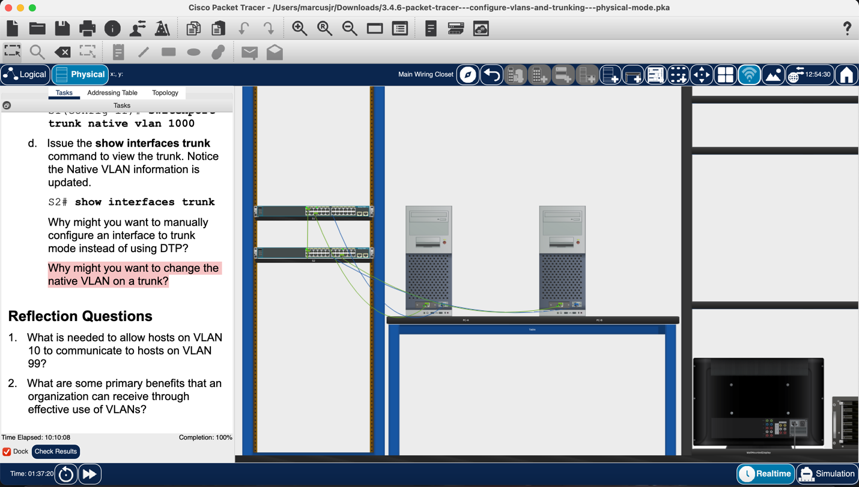

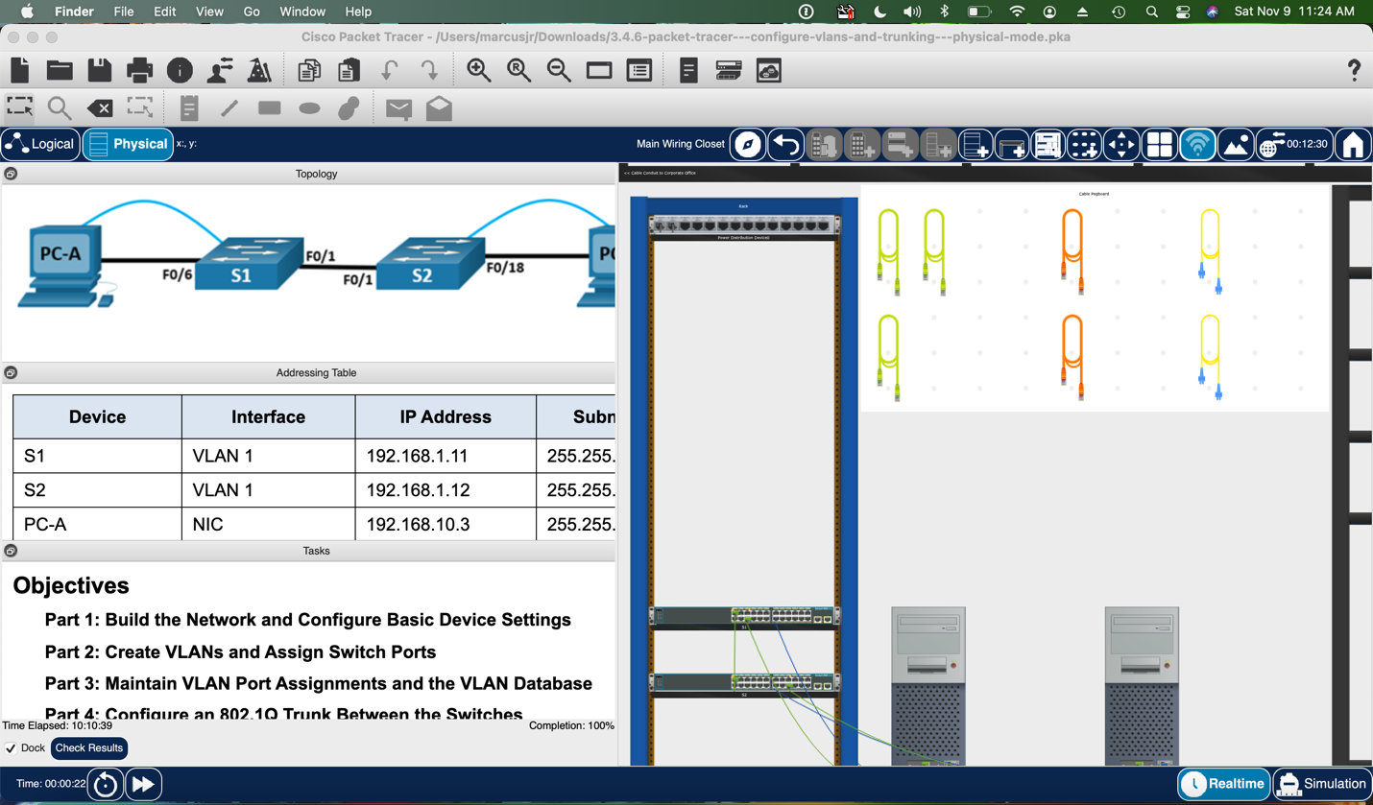

Part 1
Step 4: Test Connectivity
- Yes
- No
- No
- Yes
- The pings were unsuccessful while attempting to ping a device on a different network. For such pings to be successful, the default gateway must exist to run traffic from one subnet to another.

Part 2:
Step 1: Create VLANs on the switches
- VLAN 1
- All VLANs are connected to the default VLAN from Fa0/1 to Fa0/24 and from G0/1 to G0/2
Step 2
- The status of VLAN 99 is up and the protocol is down. The status is up because the VLAN exists in the database but the protocol is down because the VLAN has not been assigned to an active port yet.
- No, the switches' IP addresses are now in VLAN 99. VLAN 99 communication will not be transmitted over interface facility 1.
- PC-A is unable to ping PC-B; Interface facility 1 is not allocated to VLAN 10, hence VLAN 10 traffic will not be routed via it.

Part 3:
Step 2: Remove a VLAN assignment from an interface
- VLAN 1 the default VLAN
Step 3:
- The name of VLAN 30 is VLAN0030
- When you delete a VLAN, all ports that are connected or assigned to that VLAN become dormant. Port facility 24 remains linked with VLAN 30, but it is no longer displayed in the output; VLAN 30 is no longer operational since it does not exist in the VLAN database. Any ports linked with VLAN 30 will not transfer traffic.
- F0/24 is assigned back to the default VLAN (VLAN 1)
- When a VLAN is withdrawn from the VLAN database, the interfaces connected to it become dormant and cannot be used until transferred to another VLAN. It might be difficult to troubleshoot stronger interfaces that do not appear in the port list.

Part 4:
- Yes, S1 can ping S2
- Yes, PC-A can ping PC-B
- No, PC-A can not ping S1
- No, PC-B ping can not S2
- The switches are in VLAN 99 and the PCs in VLAN 10, hence the pings between VLANs were unsuccessful.
- Not all equipment uses DTP (Dynamic Trunking Protocol)
- By switching from the native VLAN to an unused VLAN, you make it more difficult for unwanted devices to access the network. If the native VLAN is misconfigured, it might cause unanticipated traffic forwarding and security problems. Changing the native VLAN can assist avoid VLAN hopping attacks, in which attackers try to acquire unauthorized access to several VLANs. In some network settings, altering the native VLAN might improve network performance.

Reflection Questions:
- To allow intermittent routing requires a layer 3 device like a layer 3 switch or a router. It is necessary to rule traffic between vlans
- VLAN benefits include better security, cost saving, efficient use of bandwidth, uplinks, higher performance, smaller broadcast domains, broadcast store mitigation, improved id staff efficiency

